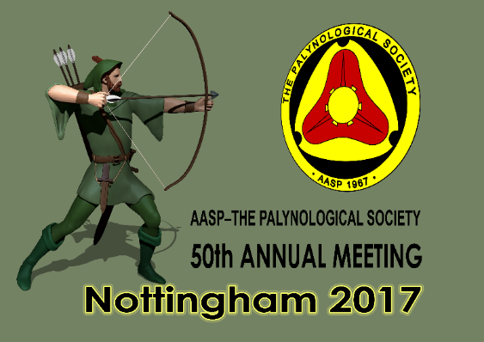

THE 50TH ANNUAL MEETING OF AASP – THE PALYNOLOGICAL SOCIETY

THE GOLDEN ANNIVERSARY MEETING HELD JOINTLY WITH CIMP AND THE MICROPALAEONTOLOGICAL SOCIETY PALYNOLOGY GROUP
KEYWORTH, NOTTINGHAM, UK – Sunday 3rd–Thursday 7th SEPTEMBER 2017

FOURTH CIRCULAR – MARCH 2017

The 50th annual meeting of AASP – The Palynological Society will be held at the British Geological Survey (BGS), Keyworth, Nottingham NG12 5GG between the 3rd and 7th of September 2017. This will be the seventh time our main yearly meeting has been held in Europe, and the third occasion it has taken place in the UK.
This conference is held jointly with CIMP and The Micropalaeontological Society (TMS) Palynology Group. The team of convenors look forward to welcoming you to the headquarters of BGS for this three-day meeting with the opportunity to participate in two one-day field trips to widely geologically contrasting areas of the East Midlands of England. There will also be a workshop on the use of StrataBugs software and another one on “Biostratigraphy: Applications to Petroleum Exploration and Production”. We hope to make this annual meeting extra special because it is the 50th such event! This is the third circular, and it will be updated very frequently. We will aim to update it at least every month between now and the meeting.
The conference accommodation will be in several city centre hotels in downtown Nottingham. Delegates will be transported to BGS HQ, and returned back to the city centre each day by bus, and as part of the registration package. BGS is located in the large village of Keyworth which is ca. 9 km south of central Nottingham. Other public transport solutions are available. Morning tea, lunch and afternoon coffee are also all included in the registration package.
If you would like to discuss sponsorship etc., or have any questions whatsoever, please get in touch with Jim Riding (jbri@bgs.ac.uk) or any of the members of the organising committee. We hope to welcome you to Keyworth for the Golden Anniversary meeting in 2017!
Please note that there is a limit on numbers of 100, that being the capacity of the BGS Conference Room where the main sessions will take place. If there are in excess of 100 delegates, we would levy a much reduced registration fee and set up a remote link to the proceedings immediately outside the conference suite. Therefore, the strong message would be to sign up in good time if you wish to guarantee your place. You should register online using the following URL: www.tmsoc.org/aasp-2017. See below for full details.

- REGISTRATION
Category | Three day price | Single day price
Professional delegate | £120 (post 1st July 2017 = £160; on the door £180) | £60
Student delegate | £50 (post 1st July 2017 = £75; on the door £85) | £25
Retired delegate | £90 (post 1st July 2017 = £110; on the door £120) | £45

Registration comprises:
- Icebreaker at “Fat Cats”, a Nottingham city centre venue on the evening of Sunday, 3rd September (includes two free drinks and some finger food)
- A conference pack including the abstract volume
- Return transport between Nottingham city centre and BGS, Keyworth, Monday through Wednesday
- Morning coffee/tea, lunch and afternoon coffee/tea
- A drinks/nibbles reception at BGS following the first day of the conference, Monday, 4th September

Optional extras:
We are also offering delegates the opportunity to attend two field trips, workshops on StrataBugs and “Biostratigraphy: Applications to Petroleum Exploration and Production”, the conference dinner and the AASP Business “Luncheon” – held at night. These will be charged separately to the core registration package. The costs for these are as follows:
ITEM | PRICE
Field trip to the Carboniferous of the Peak District (3rd September 2017) (limited to 27 persons) | £25
Conference dinner at Trent Bridge Cricket Ground (5th September 2017) | £30
AASP Business “Luncheon” held at night (6th September 2017) | £25
Field trip to Bradgate Park, Leicestershire (7th September 2017) | £25
Workshop on the use of StrataBugs software by StrataData Ltd. Held at Keyworth (am, 7th September 2017) (up to 8 persons) | free
Course on Biostratigraphy: Applications to Petroleum Exploration and Production presented by Iain Prince and Katrin Ruckwied, Shell International Exploration & Production. Held at Keyworth (7th September 2017) (up to 12 persons) | free
All of the above | £100

Note that the StrataBugs workshop, the Shell Biostratigraphy course and the Bradgate Park fieldtrip are all on Thursday 7th September. This clash is, unfortunately, impossible to avoid.

To register, please go to www.tmsoc.org/aasp-2017. Here you will find full details of how to pay using this secure website in GB Pounds Sterling via PayPal. The former URL is on the TMS website (http://www.tmsoc.org/). Should you be unable to register via this secure website, please mail a cheque for the registration package and any ‘add-ons’ you require (make these clear in a covering letter) to Jim Riding (address: BGS, Keyworth, Nottingham NG12 5GG, UK; or: jbri@bgs.ac.uk). Please make cheques payable to THE MICROPALAEONTOLOGICAL SOCIETY. If you wish to pay outwith the TMS website using a credit or debit card, send your card details to the TMS Treasurer, Matt Hampton, at treasurer@tmsoc.org for processing. You can also pay TMS direct using online banking or BACS/SWIFT payments; email the TMS Treasurer, Matt Hampton, for the account details. In all cases, please indicate your name, and precisely what you are ordering. Hopefully we have provided a variety of methods for paying your registration charges.
There is also a dedicated section of the AASP – TPS website for this conference, and this will also include details of how to register and pay. If you have any questions regarding registration, or any aspect of the conference, email Jim Riding on jbri@bgs.ac.uk.

Please note that you should make your payment (its really easy using PayPal!); them your payment will be immediately acknowledged by email by the organising committee.

- CONFERENCE PLAN

Saturday, 2nd September: In the afternoon (14.00 h–18.00 h), the outgoing Board of Directors meeting of AASP – TPS will be held at a conference room at Jurys Inn Nottingham, Station Street, Nottingham NG2 3BJ (Tel: +44 115 901 6700; Email: jurysinnnottingham@jurysinns.com). We will select a suitable meeting place for lunch near the conference hotels and Jim will guide attendees to the Jurys Inn, which is a short (~5 minutes) walk away (Jurys Inn is near Nottingham Station). All AASP – TPS members are welcome to attend this meeting as observers.

Sunday, 3rd September:
A one-day fieldtrip to examine key Carboniferous Stage stratotypes in the Peak District of Staffordshire led by Drs Duncan McLean and David Bodman (MB Stratigraphy, Sheffield). Minibuses will depart from the St James Hotel (Rutland Street, Nottingham, NG1 6EB) at 07:30 h. We will be back in Nottingham at ~18:30 h, well in time for the icebreaker. A packed lunch will be supplied. The cost of this excursion is £25, payable with the main registration. There is a maximum number of 27 due to the constraints of the sites we will visit, so please book early for this one.
An icebreaker event will be held between 19:30 h and c. 21:30 h at “The Fat Cat Cafe Bar”, a nearby trendy/funky bar in central Nottingham (http://fatcatcafebars.com/Nottingham.html). The address is 11 Chapel Bar, Nottingham NG1 6JQ (tel. 0115 947 5044). Registrants will receive two free drink vouchers, and some finger-food nibbles will be available.

Monday, 4th September: This will be the first day of the conference. Laid on buses will depart from the St James Hotel at 08:15 h. We plan to include at least one presentation on the history of AASP. Following the scientific sessions, delegates are invited to a drinks reception at BGS. This is included in the registration package and will feature local Nottingham beers (other drink solutions will be available!) and nibbles. Buses will return delegates to Nottingham.

Tuesday, 5th September: This will be the second day of the conference. Buses will depart from the St James Hotel at 08:15 h. The same vehicles will return delegates to the St James at the end of this event.
In the evening, we will hold the conference dinner. The cost of this will be £30, payable with the main registration. We have booked the “Boundary Edge” restaurant at the legendary Trent Bridge cricket ground immediately south of Nottingham (http://www.nottinghamshire.gov.uk/celebrate/venues/nottinghamshire-county-cricket-club or http://www.trentbridge.co.uk/refined/#index.php). Trent Bridge is world famous and is widely held to be the most beautiful of all our cricket stadia, and has witnessed many famous tussles between England and our distinguished pantheon of cricketing adversaries from around the world. Do not miss out on the opportunity to visit and dine at a truly iconic sporting venue. We are currently investigating possible guest speaker(s).

Wednesday, 6th September: This will be the third day of the conference. Buses will depart form the St James Hotel at 08:15 h. The same vehicles will return delegates to Nottingham.
In the evening, we will hold the AASP Business “Luncheon” held at night at (yet) another very funky downtown Nottingham venue. This will be “Cumin”, Nottingham’s leading Indian restaurant (http://www.thecumin.com/). “Cumin” is a very short walk from the hotel area at 62–64 Maid Marian Way, Nottingham NG1 6BJ (Phone: 0115 941 9941). The cost of this will be £25, payable with the main registration. This includes a buffet Indian dinner and two drinks. Indian food is the national cuisine of the UK.

Thursday, 7th September:
- A one-day fieldtrip to examine the Precambrian, Triassic and Quaternary geology of Bradgate Park, Charnwood Forest, Leicestershire led by Jim Riding. There are no restrictions on numbers. You will have the opportunity to hunt for (but not collect!) Ediacaran fossils. You will see the site where the very first representative of this world famous biota was discovered in Precambrian metasediments during the late 1950s. Minibuses will depart the St James Hotel at 08:30 h. We will be back in Nottingham at ~18:00 h. A packed lunch will be supplied. The cost of this excursion is £25, payable with the main registration.
- Delegates are also invited to a free half-day workshop on the use of StratBugs software run by Paul Britton and John Athersuch of StrataData Limited of Ottershaw, Surry, UK (http://www.stratadata.co.uk/). StrataBugs is a very well-established (the industry standard in fact) software package for displaying and manipulating biostratigraphical data of all types. This workshop will be held between 09:00 h and 12:30 h at a conference room at Keyworth and will give novices and beginners the opportunity to get some hands-on experience with StrataBugs. It will also be a refresher for those who have used the software before. If you wish to attend this bring your laptop. The workshop will be subject to a maximum of eight persons, so book early!
- Up to 12 delegates are invited to register for a free course entitled: Biostratigraphy: Applications to Petroleum Exploration and Production by Iain Prince and Katrin Ruckwied of Shell International Exploration & Production, Houston, USA. This workshop will be held between 09:00 h and 17:30 h at a conference room at Keyworth. It is a concise introduction of how to maximise micropalaeontological data in an industrial setting. Specifically, the course will give a brief overview of the fossil groups used within the petroleum industry before looking into why we use biostratigraphy and how it can help in the exploration and production process. After a short practical where groups horizontally steer a production well using biostratigraphical data, some case studies will be shown highlighting how biostratigraphy can either reduce drilling costs, drill safer wells or help obtain more accurate data.
- In the evening, (~20.00 h-21.30 h), the incoming Board of Directors meeting of AASP – TPS will be held at a venue to be announced later. One option is to use the conference room at Jurys Inn Nottingham, Station Street, Nottingham NG2 3BJ (Tel: +44 115 901 6700; Email: jurysinnnottingham@jurysinns.com) (see above). All members are welcome to attend as observers.

- TRAVELLING TO NOTTINGHAM (AND BACK)
All UK residents will be fully aware that the fair city of Nottingham is one of the most accessible in the country, being situated in the centre of England and slap bang on major road and rail links. See http://www.experiencenottinghamshire.com/nottingham.
Overseas visitors can fly to Birmingham, East Midlands, London or Manchester airports. Any of the several London airports are absolutely fine. All these airports allow for efficient rail travel to Nottingham except for the most local one, East Midlands (EMA). If you go to EMA, take a cab/taxi or bus (Nottingham Skylink; see https://www.trentbarton.co.uk/services/skylinknottingham/welcome) to Nottingham.
Long haul travellers are most likely to arrive at Heathrow or Gatwick airports in London. In this case, simply take the rail shuttle (Heathrow or Gatwick Express) to central London and head on the metro/underground for St Pancras mainline station (this is at Kings Cross/St Pancras metro/underground station). From St Pancras, frequent and fast trains will whizz you to Nottingham in just a couple of hours. If you have any questions about travel to Nottingham, email Jim Riding (jbri@bgs.ac.uk).

- ACCOMMODATION
We recommend that you use either the St James Hotel, Rutland Street, Nottingham, NG1 6EB (http://www.stjames-hotel.com/) or the Premier Inn Nottingham City (Chapel Bar), 7 Chapel Quarter, Maid Marian Way, Nottingham NG1 6JS (Tel: 0871 527 9658; or see http://www.premierinn.com/gb/en/hotels/england/nottinghamshire/nottingham/nottingham-city-centre-chapel-bar.html). These are “nice but not too pricey” city centre hotels very close to great bars, historic sites, restaurants etc. They are both reasonably priced.
We have negotiated a special deal with the St James Hotel. To take advantage of this discount you need to telephone (+44(0)115 941 1114) or fax (+44(0)115 9410014), or email the hotel (info@stjames-hotel.com), and quote GA000471.
There are no group rates available at the Premier Inn so the best way to book is online; please do ensure you book their Chapel Bar Hotel – there are two other Premier Inns in Nottingham!
However, other accommodation is of course available; there are many hotels and apartments in the city including representatives of the major well-known chains such as Ibis, Jurys Inn, Park Plaza, Premier Inn, Ramada, Strathdon, Travelodge etc. Check out the respective websites.

- LOCAL TRAVEL
Travel between central Nottingham to BGS is provided, but we appreciate you might need to go your own way. The village of Keyworth is located around six miles (~9 km) south of central Nottingham. A cab/taxi will cost around £15 one way. Other public travel solutions are also available. From Nottingham, you can catch a bus to Keyworth, the Keyworth Connection (https://www.trentbarton.co.uk/services/keyworthconnection/maps-and-times), which runs from the Broadmarsh Bus Station in central Nottingham. This bus route travels via Nottingham railway station, through the suburb of West Bridgford and on to Keyworth. A single journey costs around £3 and takes about 25 minutes, depending on traffic.

- THE SCIENTIFIC PROGRAMME
Delegates may submit abstracts from now. The deadline is Monday, 10th July 2017. You may submit oral presentations (15–20 minutes) or present a poster. Please email abstracts to jbri@bgs.ac.uk and janh@bgs.ac.uk. Please use Times New Roman 12 point font, single-spaced, left justified, no more than ~1000 words, include keywords, and also provide your affiliation, address and email.

The organising committee:
James B. Riding (BGS, representing AASP - TPS)
Jan A.I. Hennissen (BGS, representing AASP - TPS)
Stewart G. Molyneux (BGS, representing AASP - TPS)
Matthew J. Pound (Northumbria University, representing TMS)
Reed Wicander (CMU, Mount Pleasant, USA, representing CIMP)
Maria Wilson (BGS)

Pre-Conference field trip to the Carboniferous of the Peak District, south Derbyshire and North Staffordshire
Sunday 3rd September 2017
Led by Drs Duncan McLean and David Bodman (MB Stratigraphy Limited, Sheffield; email: mbstratigraphy@gmail.com)

Overview: This is a fantastic opportunity for up to 27 delegates to examine the Carboniferous strata of central England, including the boundary stratotype sections of several European substages. We will visit some localities of outstanding natural beauty in the Peak District National Park, the UK’s first such protected area. There will be a little walking involved over relatively rough ground and two of the sections are in streams (see below).
Aims:
- To examine facies representative of the Viséan to Westphalian basin fill on the southern margin of the Pennine Basin and to understand these in terms of the onshore and offshore Carboniferous petroleum systems.
- To visit Substage boundary stratotype sections that are the focus of ongoing palynological work and that provide key locations for the developing British Carboniferous miospore biozonation.
Itinerary:
1. Location to be decided. Exposure of Viséan platform carbonates.
2. Crowdecote and upper Dovedale. Views of the Viséan platform margin with scenic reef knolls of Chrome Hill. Nature of the contact with basinal mudstones of Viséan to Namurian age. Development and provenance of Namurian turbidite facies.
3. Blake Brook. Alportian stratotype. Chokierian turbidites overlain by Alportian to Kinderscoutian goniatite-bearing hemipelagic mudstones. Nature and significance of Late Carboniferous marine bands. Opportunity to collect goniatites.
4. Flash. Lunch stop at the highest village in Britain!
5. Orchard Farm. Yeadonian stratotype. Marsdenian to Yeadonian goniatite-bearing hemipelagic mudstones. Opportunity to collect goniatites and bivalves.
6. Ramshaw Rocks. Marsdenian sandstones representing deltaic infill of the basin. Sedimentology and provenance. Overview of the Goyt Syncline.
7. Derbyshire Bridge (time permitting). Early Langsettian coal measures.
8. En route. It will be possible to pass Brassington where dolomitised Viséan limestones and associated pocket deposits of the Miocene Brassington Formation are exposed.
Field trip participants will each be given a field guide and a representative set of palynological slides from the Alportian and Yeadonian stratotype sections.
Logistics: Transportation will depart from the St James Hotel (Rutland Street, Nottingham, NG1 6EB) at 07:30 h sharp. The distance between central Nottingham and Dovedale is ~33 miles and the journey normally takes around one hour. We will be back in Nottingham at ~18:30 h, well in time for the icebreaker. A packed lunch will be supplied. Flash, where we will take lunch, has a tiny cafe/shop where participants can top-up their packed lunches, or get a hot drink. There is also a pub in the village.
Please note that the two stratotypes are stream sections. It is not possible to get to the Alportian section without some wading in the river. Please can UK-based participants bring wellington boots for this? The organisers can probably provide spare pairs of wellington boots (various sizes) for some of the international visitors.
Cost: £25 including transport, packed lunch, field guide and a set of palynomorph slides from the Alportian and Yeadonian sections visited.

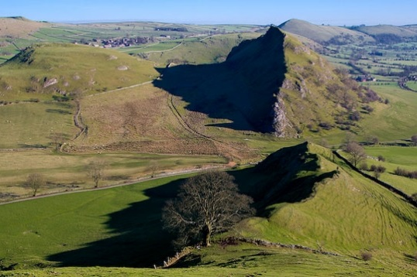
Chrome Hill, Derbyshire (SK 070 673). Apron reef facies in the Bee Low Limestone Formation (Asbian, mid Viséan, mid Mississippian, Carboniferous).

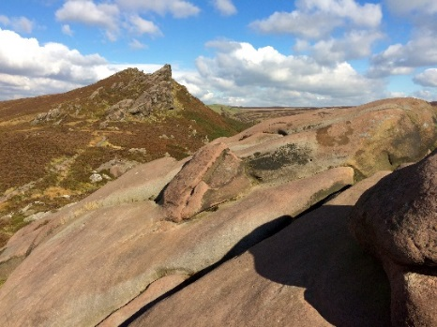
Ramshaw Rocks, Staffordshire (SK 019 622). Delta-top sandstones of the Roaches Grit, Marsden Formation (Marsdenian, Bashkirian, early Pennsylvanian, Carboniferous).
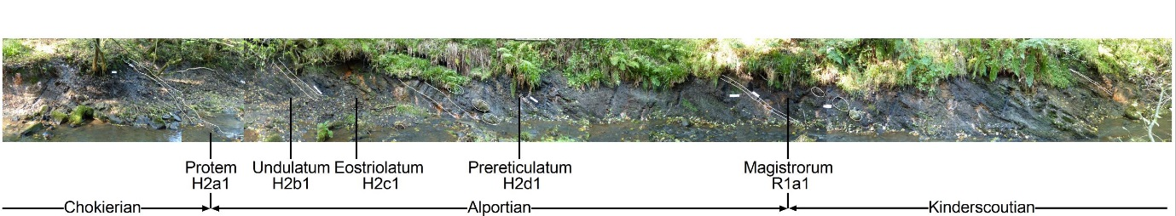
The Alportian Substage stratotype section at Blake Brook, Staffordshire (SK 062 611). This is 12 m of dark, fossiliferous, hemipelagic mudstones of the Morridge Formation. The late Chokierian to early Kinderscoutian succession (Bashkirian, early Pennsylvanian, Carboniferous) is illustrated here.

Post-Conference field trip to Bradgate Park, Charnwood Forest, Leicestershire
Thursday 7rd September 2017
Led by Jim Riding (BGS)

Overview: This is an excellent introduction to the geology of the Charnwood Forest area of Leicestershire – one of the classic regions of British geology. We will observe Precambrian, Cambrian, Triassic and Quaternary igneous rocks, metasediments and sediments in Bradgate Park. One of the highlights will be the opportunity to see the locality when the famous Neoproterozoic Ediacaran fauna was discovered and understood as fossils in the late 1950s (see below). There is no limit on numbers. The excursion will involve a single circular geological walk of approximately 8 km. The park is a well-known local beauty spot and there is much historical and natural history interest. If you are from outside the UK, do not miss this one!
The coach(es) will park at the Hunts Hill (Old John) car park (Grid. Reference SK 5232 1167). If you wish to travel independently, it can be reached by turning right off the B5330 (assuming you are approaching from the north), just north of Swithland. Or, for those of you with a large-scale map, it is at the south end of Benscliffe Road. From Leicester, at the ‘T’-junction in Newton Linford, turn left and drive up Sharpley Hill. Hunts Hill car park is signposted on the right after ca. 1.5 km. This is a pay and display car park and you will have to obtain a valid ticket for the day. The trip will end at the Hunts Hill car park. The relevant Ordnance Survey Explorer map is number 246 (Loughborough, Melton Mowbray and Syston).
We will be examining metamorphic (metasedimentary), sedimentary and igneous rocks. There is no need for hard hats, and geological hammers cannot be used in the park. Please do not bring your geological hammer!
The famous Ediacaran fossil Charnia masoni was discovered by Roger Mason, a schoolboy who later became a geologist (professor of metamorphic petrology!). In 1957 Roger and his friends were rock climbing and they noticed this unusual fossil, and took a rubbing of it. Roger Mason took a local geologist, Trevor D. Ford to the site; Ford later described Charnia masoni in 1959 (‘Pre-Cambrian fossils from Charnwood Forest’. Proceedings of the Yorkshire Geological Society, Volume 31, pp. 211–217, doi: 10.1144/pygs.31.3.211). The holotype is housed at New Walk Museum and Art Gallery, Leicester. After the formalisation of Charnia masoni, it transpired that Tina Negus, who was then a 15 year old schoolgirl, had seen this fossil one year before Roger Mason and his friends, but her teacher did not think it was possible that fossils could be present in Precambrian metasediments!
The walk will largely be on established footpaths, but will be relatively rough in places, and involve some moderate slopes. You will require suitable clothing for British Summer conditions, including strong shoes or walking boots, in addition to any personal effects such as suncream, insect repellent and personal first aid items. There will be a lunch break en route. A packed lunch will be provided. Toilets will be available at certain points along the way.
Background reading:
McGrath, A. 2004. A geological walk around Bradgate Park and Swithland Wood. British Geological Survey, 31 p.
Ambrose, K., Carney, J.N., Lott, G.K., Weightman, G., and McGrath, A. 2007. Exploring the landscape of Charnwood Forest and Mountsorrel. A walker’s guide showing the rocks and landscape of Charnwood Forest and Mountsorrel. British Geological Survey, 52 p. plus map.

